

Title

Title

Title

Title (Max 15 words)

by

Student Name

(matric number)

A Choose an item. submitted in Choose an item. of the requirements for the degree of

Choose an item.

Choose an item.

UNIVERSITI MALAYSIA PERLIS

20XX

UNIVERSITI MALAYSIA PERLIS

DECLARATION OF THESIS

|  |  |  |
| --- | --- | --- |
| Author’s Full Name | : | WAN ZUKI AZMAN WAN MUHAMAD |
| Title | : | NEW DIMENSION IN MULTIVARIATE PATTERN RECOGNITION FOR THE APPLICATION OF INDUSTRIAL PROCESS TECHNOLOGY INDUSTRIAL PROCESS TECHNOLOGY INDUSTRIAL PROCESS TECHNOLOGY |
| Date of Birth | : | 20 OCTOBER 1989 |
| Date of Registration | : | 20 JANUARY 2019 |
| Academic Session of Thesis Submission | : | 2021/2022 |

I hereby declare that this Choose an item. becomes the property of Universiti Malaysia Perlis (UniMAP) and to be placed at the library of UniMAP. This Choose an item. is classified as:

|  |  |  |  |  |  |
| --- | --- | --- | --- | --- | --- |
|  |  | CONFIDENTIAL | | (Contains confidential information under the Official Secret Act 1997)* | |
|  |
|  |  | RESTRICTED | (Contains restricted information as specified by the organization where research was done)* | |
|  |
|  | ✓ | OPEN ACCESS | I agree that my Choose an item. to be published as online open access (Full Text) | |
|  |

I, the author, give permission to reproduce this Choose an item. in whole or in part for the purpose of research or academic exchange only (except during the period of _______ years, if so requested above)

|  |  |  |  |
| --- | --- | --- | --- |
|  |  |  | Certified by: |
|  |  |  |  |
|  |  |
|  | **SIGNATURE** |  | **SIGNATURE OF SUPERVISOR** |
|  |  |  |  |
|  | 777777777777 |  | PROF. DR. MOHD YUSOF MASHOR |
|  | **(NEW IC NO. /PASSPORT NO.)** |  | **NAME OF SUPERVISOR** |
|  | Date: 20 October 2016 |  | Date: 25 December 2016 |

**NOTES** : * If the thesis is CONFIDENTIAL or RESTRICTED, please attach with the letter from the organization with the period and reasons for confidentiality or restriction.

ACKNOWLEDGEMENT

On the Insert tab, the galleries include items that are designed to coordinate with the overall look of your document. You can use these galleries to insert tables, headers, footers, lists, cover pages, and other document building blocks. When you create pictures, charts, or diagrams, they also coordinate with your current document look.

You can easily change the formatting of selected text in the document text by choosing a look for the selected text from the Quick Styles gallery on the Home tab. You can also format text directly by using the other controls on the Home tab. Most controls offer a choice of using the look from the current theme or using a format that you specify directly.

To change the overall look of your document, choose new Theme elements on the Page Layout tab. To change the looks available in the Quick Style gallery, use the Change Current Quick Style Set command. Both the Themes gallery and the Quick Styles gallery provide reset commands so that you can always restore the look of your document to the original contained in your current template.

TABLE OF CONTENTS

**PAGE**

DECLARATION OF THESIS i

ACKNOWLEDGEMENT ii

TABLE OF CONTENTS iii

LIST OF TABLES v

LIST OF FIGURES vi

LIST OF ABBREVIATIONS vii

LIST OF SYMBOLS viii

ABSTRAK ix

ABSTRACT x

CHAPTER 1 : INTRODUCTION 1

1.1 UniMAP Thesis Template 1

1.1.2 Developer Tab 2

1.1.3 Navigation Pane 2

1.1.4 Styles Pane 3

1.2 Research Objective 5

1.3 Summary 6

CHAPTER 2 : LITERATURE REVIEW 7

2.1 Heading 1 7

2.2 Heading 2 7

2.2.1 Heading 3 7

2.2.1.1 Long long long long long long long long long long long long long long Heading 4 7

2.3 Other important styles 7

2.4 Equations 8

2.5 Quote 8

CHAPTER 3 : METHODOLOGY 10

3.1 Introduction 10

3.2 Heading 1 10

3.3 Long long long long long long long long long long long long long long long long Heading 2 10

3.3.1 Long long long long long long long long long long long long long long long long Heading 3 10

3.4 Other important styles 10

3.5 Equations 11

3.6 Quote 11

CHAPTER 4 : RESULTS & DISCUSSION 13

4.1 Introduction 13

CHAPTER 5 : CONCLUSION 14

5.1 Introduction 14

5.2 Citation APA Style Edition 14

REFERENCES 16

APPENDIX A SAMPLE APPENDIX 1 17

APPENDIX B SAMPLE APPENDIX 2 18

LIST OF PUBLICATIONS 19

LIST OF TABLES

|  |  |
| --- | --- |
|  | Page |

Table ‎2.1 Sample table The text in paragraph can be formatted using *Table text* style. On the other hand, the style for table’s caption is called *Caption for Table UniMAP* 9

Table ‎3.1 Sample table 12

LIST OF FIGURES

|  |  |
| --- | --- |
|  | PAGE |

Figure ‎1.1 Enabling the Developer Tab 2

Figure ‎1.2 Navigation Pane 3

Figure ‎1.3 Enabling Styles Pane 4

Figure ‎1.4 This is just a simulation. Syles Pane on right side of the window Once the PC is ready, you can familiarize yourself with the styles in this template. Some of the styles will be explained in Chapter 2 4

LIST OF ABBREVIATIONS

|  |  |
| --- | --- |
| APM | Airborne particulate matter |
| BBB | blood-brain barrier |
| BMU | Best Matching Unit |
| CMB | Chemical Mass Balance |
| CPCA | Consensus PCA |
| CSI | Class Separation Indices |
| CSM | Class Sample Matrix |
| CSV | Class Sample Vector |
| CWM | Class Weight Matrix |
| CWV | Class Weight Vector |
| EDC | Euclidean Distance to Centriods |

LIST OF SYMBOLS

|  |  |
| --- | --- |
| A | Number of PLS or PCA components in the model |
| a | Number of the PLS or PCA component |
| **b** | PLS regression coefficient |
| b | Number of blocks (b=1,2,3.....,K) |
| **C** | Coarse APM block |
|  | Pooled covariance matrix for the two classes |
|  |  |
|  |  |
|  |  |
|  |  |
|  |  |
|  |  |
|  |  |
|  |  |
|  |  |
|  |  |
|  |  |
|  |  |

Penolakan Algoritma Penolakan Latar Belakang Untuk Pengenalpastian Muka Biometrik (Maksimum 15 patah perkataan)

ABSTRAK

On the Insert tab, the galleries include items that are designed to coordinate with the overall look of your document. You can use these galleries to insert tables, headers, footers, lists, cover pages, and other document building blocks. When you create pictures, charts, or diagrams, they also coordinate with your current document look. You can easily change the formatting of selected text in the document text by choosing a look for the selected text from the Quick Styles gallery on the Home tab. You can also format text directly by using the other controls on the Home tab. Most controls offer a choice of using the look from the current theme or using a format that you specify directly. To change the overall look of your document, choose new Theme elements on the Page Layout tab. To change the looks available in the Quick Style gallery, use the Change Current Quick Style Set c

Development of Background Subtraction Algorithm for Biometric Identification

ABSTRACT

On the Insert tab, the galleries include items that are designed to coordinate with the overall look of your document. You can use these galleries to insert tables, headers, footers, lists, cover pages, and other document building blocks. When you create pictures, charts, or diagrams, they also coordinate with your current document look. You can easily change the formatting of selected text in the document text by choosing a look for the selected text from the Quick Styles gallery on the Home tab. You can also format text directly by using the other controls on the Home tab. Most controls offer a choice of using the look from the current theme or using a format that you specify directly. To change the overall look of your document, choose new Theme elements on the Page Layout tab. To change the looks available in the Quick Style gallery, use the Change Current Quick Style Set command. Both the Themes gallery and the Quick Styles gallery provide reset commands so that you can always restore the look of your document to the original contained in your current template. On the Insert tab, the galleries include items that are designed to coordinate with the overall look of your document. You can use these galleries to insert tables, headers, footers, lists, cover pages, and other document building blocks. When you create pictures, charts, or diagrams, they also coordinate with your current document look. You can easily change the formatting of selected text in the document text by choosing a look for the selected text from the Quick Styles gallery on the Home tab. You can also format text directly by using the other controls on the Home tab. Most controls offer a choice of using the look from the current theme or using a format that you specify directly. To change the overall look of your document, choose new Theme elements on the Page Layout tab. To change the looks available in the Quick Style gallery, use the Change Current Quick Style Set command. Both the Themes gallery and the Quick Styles gallery provide reset commands so that you can always restore the look of your document to the original contained in your current template. On the Insert tab, the galleries include items that are designed to coordinate with the overall look of your document. You can use these galleries to insert tables, headers, footers, lists, cover pages, and other document building blocks.

# INTRODUCTION

## UniMAP Thesis Template

Thesis formatting has long been one of the nightmares for every postgraduate candidate. More often than not, students find themselves spend more time than they expected in formatting their thesis. Starting from 2016, Universiti Malaysia Perlis (UniMAP) provides Microsoft Word template for thesis formatting to the postgraduates. This module aims to guide the user (both postgraduates and undergraduates) to use the template effectively. The module is written in procedural based manner; where step by step instructions are given with appropriate visual aids. It is designed to be best read with self-practice on computer simultaneously.

###### Video provides a powerful way to help you prove your point.

###### When you click Online Video, you can paste in the embed code for the video you want to add.

###### You can also type a keyword to search online for the video that best fits your document.

This document is the template created to ease the thesis writing. The file is in .dotx extension, a dedicated file extension for template in Microsoft Word. Before this template is applied, it is important that you get your computer ready. There are several Microsoft Word features that you should enable first.

### Developer Tab

To create a new thesis based on this template, just double click the file. A new document will open in Microsoft Word, normally named Untitled.docx. You can start put your content in that file without having to worry about the thesis formatting. However, if you want to apply this dotx template to your current thesis, you need to enable the Developer Tab option. To do so, please refer to Figure ‎1.1.

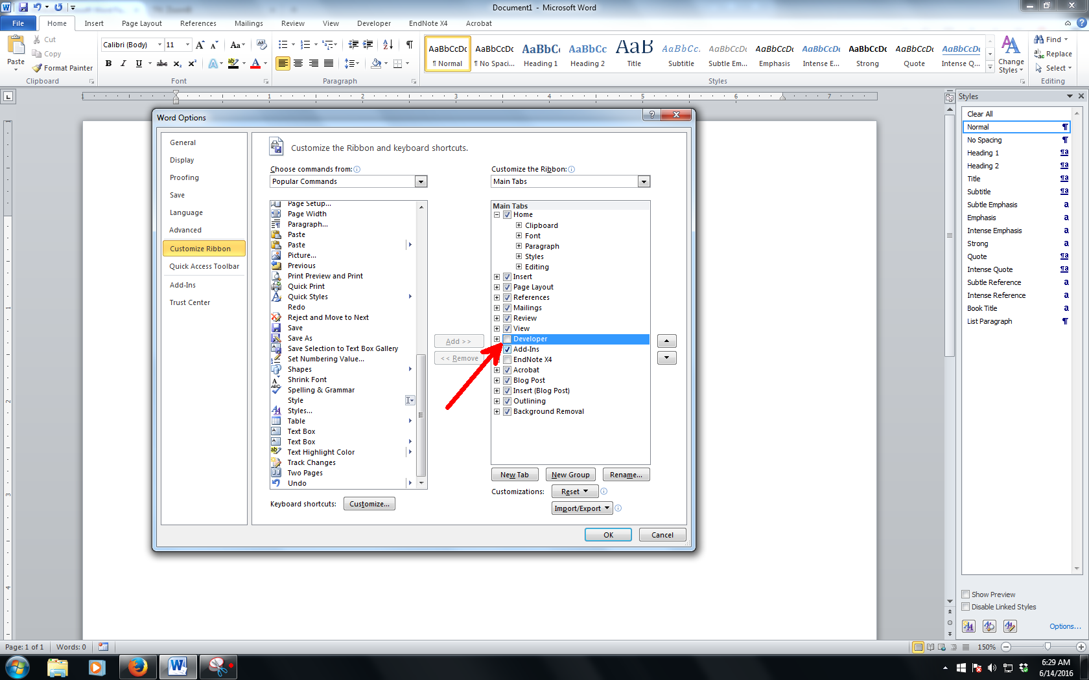

Figure ‎1.1 Enabling the Developer Tab

Source: Zuli (2016). Use style named *Caption for text in Figure UniMAP* for any text here.

### Navigation Pane

Navigation pane is where you can browse through your thesis based on its heading name. To enable it, please refer to Figure ‎1.2. The option to enable navigation pane resides in View ribbon.

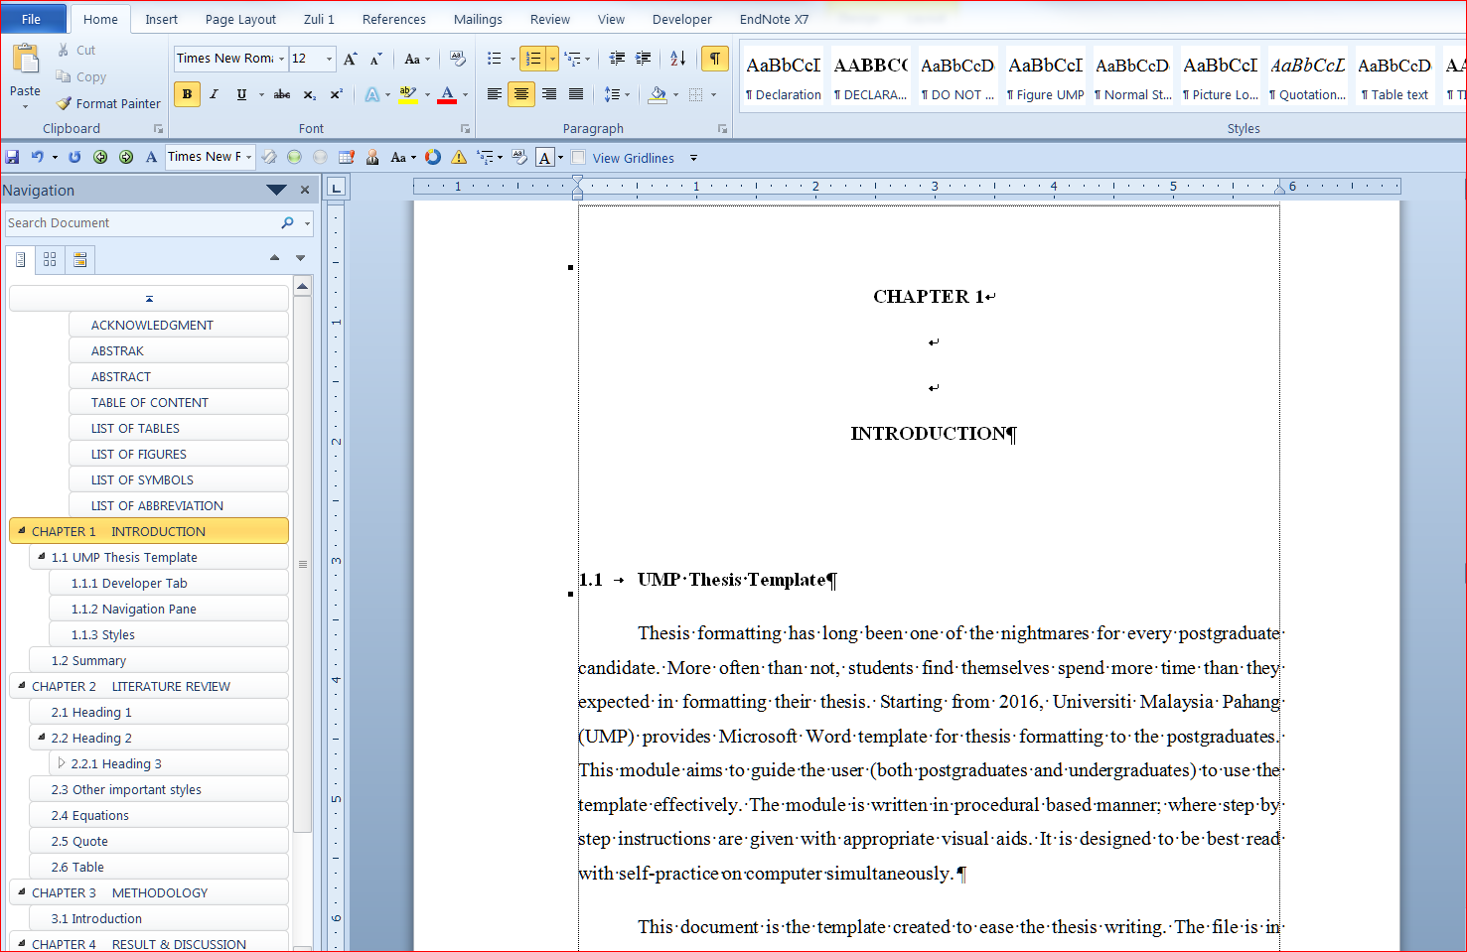

Figure ‎1.2 Navigation Pane

### Styles Pane

The basic of applying template is Styles. Styles is predefined formatting of text and paragraph. It is most efficient that you put the Styles pane on the right side of the Microsoft Word working environment by click a small arrow as shown in Figure ‎1.3. If your pane is floating, click and hold the windows and put it at the right side of the windows.

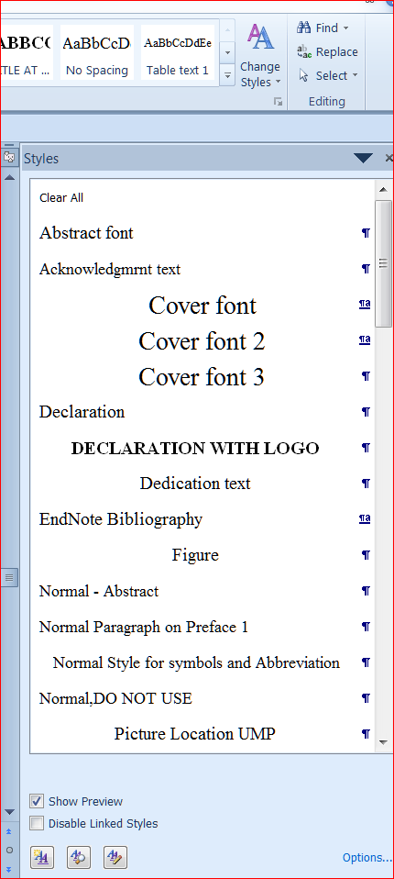

Figure ‎1.3 Enabling Styles Pane

Once secured on the right side of the working environment, the Styles Pane should look like Figure ‎1.4.

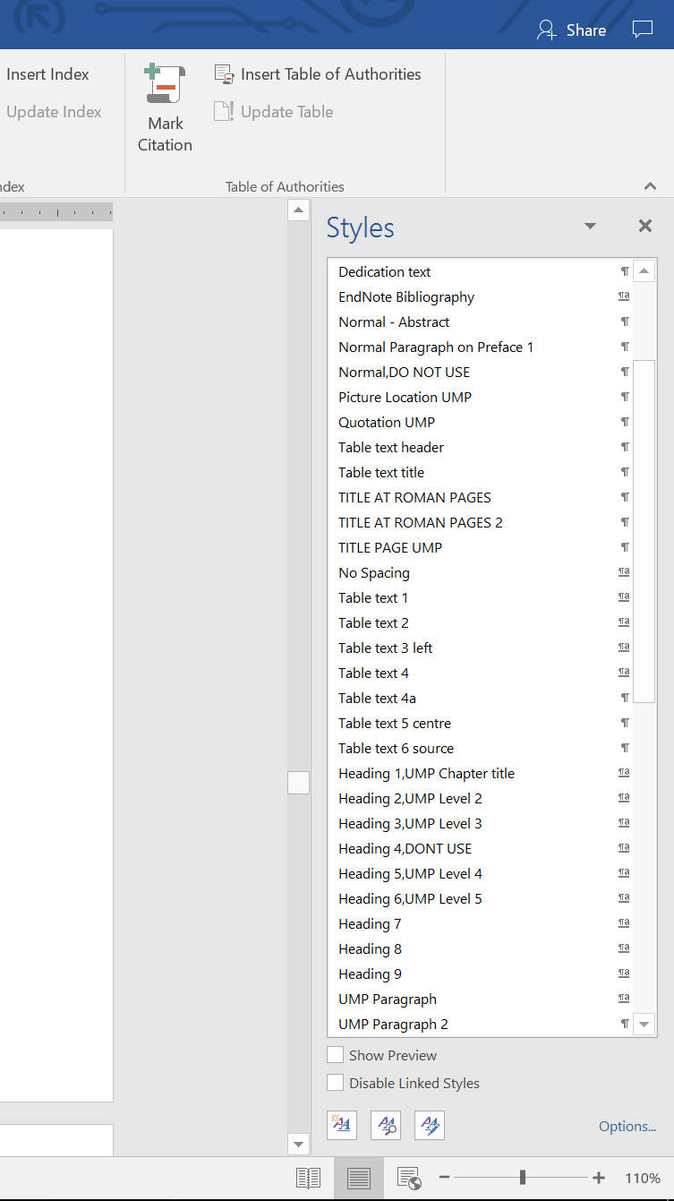

Figure ‎1.4 This is just a simulation. Syles Pane on right side of the window Once the PC is ready, you can familiarize yourself with the styles in this template. Some of the styles will be explained in Chapter 2

Video provides a powerful way to help you prove your point. When you click Online Video, you can paste in the embed code for the video you want to add. You can also type a keyword to search online for the video that best fits your document.

To make your document look professionally produced, Word provides header, footer, cover page, and text box designs that complement each other. For example, you can add a matching cover page, header, and sidebar. Click Insert and then choose the elements you want from the different galleries.

Themes and styles also help keep your document coordinated. When you click Design and choose a new Theme, the pictures, charts, and SmartArt graphics change to match your new theme. When you apply styles, your headings change to match the new theme.

Video provides a powerful way to help you prove your point. When you click Online Video, you can paste in the embed code for the video you want to add. You can also type a keyword to search online for the video that best fits your document.

To make your document look professionally produced, Word provides header, footer, cover page, and text box designs that complement each other. For example, you can add a matching cover page, header, and sidebar. Click Insert and then choose the elements you want from the different galleries.

## Research Objective

The aim pf this thesis is to develop a modified Mahalanobis Taguchi System by using Particle Swarm Optimization. The objectives of this study are :

##### Video provides a powerful way to help you prove your point.

##### When you click Online Video, you can paste in the embed code for the video you want to add.

##### You can also type a keyword to search online for the video that best fits your document.

##### To make your document look professionally produced, Word provides header, footer, cover page, and text box designs that complement each other.

## Summary

Once the PC is ready, you can familiarize yourself with the styles in this template. Some of the styles will be explained in Chapter 2.

# LITERATURE REVIEW

## Heading 1

Heading 1 is used for chapter naming. In this template, it is called *Heading 1, UniMAP Chapter Title*. In most cases, thesis will have around five to seven chapters.

## Heading 2

The styles used for this subchapter 2.2 is *Heading 2, UniMAP Level 2*.

### Heading 3

The heading for Subchapter 2.2.1 is formatted with *Heading 3, UniMAP Level 3*.

#### Long long long long long long long long long long long long long long Heading 4

## Other important styles

All styles developed in this template are essential to a proper thesis formatting. The most widely used style is UniMAP Paragraph. This very paragraph is formatted by *UniMAP Paragraph* syles.

Another important one is the caption styles. All pictures in this template are formatted by using *Caption for Equation* styles.

## Equations

As shown in Equation (‎2.1, all equations must be systematically numbered. To insert any equation, copy the whole equation and numbering below and paste on your desired location. After that, edit the equation. The style for equation is *Caption for Equation UniMP*.

|  |  |
| --- | --- |
|  | (‎2.1) |

The paragraph after an equation of a figure, has to be formatted in *UniMAP Paragraph 2*. This is to allow some space between the paragraph and the equation or the figure’s caption. This paragraph is using *UniMAP Paragraph 2* style.

## Quote

To insert a quote like this, use *Quotation UniMAP* style. Please ensure all quotation are properly cited.

On the Insert tab, the galleries include items that are designed to coordinate with the overall look of your document. You can use these galleries to insert tables, headers, footers, lists, cover pages, and other document building blocks.

The text in paragraph can be formatted using *Table text* style. On the other hand, the style for table’s caption is called *Caption for Table UniMAP*.

Table ‎2.1 Sample table The text in paragraph can be formatted using *Table text* style. On the other hand, the style for table’s caption is called *Caption for Table UniMAP*

|  |  |
| --- | --- |
| Test | Text |
| Test | Text |
| Test | Text |
| Test | Text |
| Test | Text |

# METHODOLOGY

## Introduction

## Heading 1

Heading 1 is used for chapter naming. In this template, it is called *Heading 1, UniMAP Chapter Title*. In most cases, thesis will have around five to seven chapters.

## Long long long long long long long long long long long long long long long long Heading 2

The styles used for this subchapter 2.2 is *Heading 2, UniMAP Level 2*.

### Long long long long long long long long long long long long long long long long Heading 3

The heading for Subchapter 2.2.1 is formatted with *Heading 3, UniMAP Level 3*.

## Other important styles

All styles developed in this template are essential to a proper thesis formatting. The most widely used style is UniMAP Paragraph. This very paragraph is formatted by *UniMAP Paragraph* syles.

Another important one is the caption styles. All pictures in this template are formatted by using *Caption for Equation* styles.

## Equations

As shown in Equation (‎2.1, all equations must be systematically numbered. To insert any equation, copy the whole equation and numbering below and paste on your desired location. After that, edit the equation. The style for equation is *Caption for Equation UniMAP*

|  |  |
| --- | --- |
|  | (‎3.1) |

The paragraph after an equation of a figure, has to be formatted in *UniMAP Paragraph 2*. This is to allow some space between the paragraph and the equation or the figure’s caption. This paragraph is using *UniMAP Paragraph 2* style.

## Quote

To insert a quote like this, use *Quotation UniMAP* style. Please ensure all quotation are properly cited.

On the Insert tab, the galleries include items that are designed to coordinate with the overall look of your document. You can use these galleries to insert tables, headers, footers, lists, cover pages, and other document building blocks.

The text in paragraph can be formatted using *Table text* style. On the other hand, the style for table’s caption is called *Caption for Table UniMAP*.

Table ‎3.1 Sample table

|  |  |
| --- | --- |
| Test | Text |
| Test | Text |
| Test | Text |
| Test | Text |
| Test | Text |

# RESULTS & DISCUSSION

## Introduction

# CONCLUSION

## Introduction

## Citation APA Style Edition

|  |  |  |
| --- | --- | --- |
|  |  |  |
|  |  |  |

This is example Table in landscape orientation.

REFERENCES

Berndt, T. J. (2002). Friendship quality and social development. Current Directions in Psychological Science, 11, 7-10. http://doi.org/10.1111/1467-8721.00157.

Harris, M., Karper, E., Stacks, G., Hoffman, D., DeNiro, R., Cruz, P., et al. (2001). Writing labs and the Hollywood connection. Journal of Film and Writing, 44(3), 213-245.

Kernis, M. H., Cornell, D. P., Sun, C. R., Berry, A., & Harlow, T. (1993). There's more to self-esteem than whether it is high or low: The importance of stability of self-esteem. Journal of Personality and Social Psychology, 65, 1190-1204.

Laplace, P. S. (1951). A philosophical essay on probabilities (F. W. Truscott & F. L. Emory, Trans.). New York: Dover. (Original work published 1814)

O'Neil, J. M., & Egan, J. (1992). Men's and women's gender role journeys: Metaphor for healing, transition, and transformation. In B. R. Wainrib (Ed.), Gender issues across the life cycle (pp. 107-123). New York: Springer.

Wegener, D. T., & Petty, R. E. (1994). Mood management across affective states: The hedonic contingency hypothesis. Journal of Personality & Social Psychology, 66, 1034-1048.

APPENDIX A  
SAMPLE APPENDIX 1

For Appendices Heading use TITLE AT ROMAN PAGES style.

APPENDIX B  
SAMPLE APPENDIX 2

For Appendices Heading use APPENDIX style.

LIST OF PUBLICATIONS