

TITLE

TITLE

TITLE

TITLE

TITLE

by

STUDENT NAME

(matric number)

A Choose an item. submitted in Choose an item. of the requirements for the degree of

Choose an item.

Name of School

UNIVERSITI MALAYSIA PERLIS

2016

UNIVERSITI MALAYSIA PERLIS

DECLARATION OF Choose an item.

|  |  |  |
| --- | --- | --- |
| Author’s Full Name | : | WAN ZUKI AZMAN WAN MUHAMAD |
| Title | : | NEW DIMENSION IN MULTIVARIATE PATTERN RECOGNITION FOR THE APPLICATION OF INDUSTRIAL PROCESS TECHNOLOGY INDUSTRIAL PROCESS TECHNOLOGY INDUSTRIAL PROCESS TECHNOLOGY |
| Date of Birth | : | 20 OCTOBER 2016 |
| Academic Session | : | 2016/2017 |

I hereby declare that this Choose an item. becomes the property of Universiti Malaysia Perlis (UniMAP) and to be placed at the library of UniMAP. This Choose an item. is classified as:

|  |  |  |  |  |  |
| --- | --- | --- | --- | --- | --- |
|  |  | CONFIDENTIAL | | (Contains confidential information under the Official Secret Act 1997)* | |
|  |
|  |  | RESTRICTED | (Contains restricted information as specified by the organization where research was done)* | |
|  |
|  | ✓ | OPEN ACCESS | I agree that my Choose an item. to be published as online open access (Full Text) | |
|  |

I, the author, give permission to reproduce this Choose an item. in whole or in part for the purpose of research or academic exchange only (except during the period of _______ years, if so requested above)

|  |  |  |  |
| --- | --- | --- | --- |
|  |  |  | Certified by: |
|  |  |  |  |
|  |  |
|  | **SIGNATURE** |  | **SIGNATURE OF SUPERVISOR** |
|  |  |  |  |
|  | 777777777777 |  | PROF. DR. MOHD YUSOF MASHOR |
|  | **(NEW IC NO. /PASSPORT NO.)** |  | **NAME OF SUPERVISOR** |
|  | Date: 20 October 2016 |  | Date: 25 December 2016 |

**NOTES** : * If the thesis is CONFIDENTIAL or RESTRICTED, please attach with the letter from the organization with the period and reasons for confidentiality or restriction. Replace thesis with dissertation (MSc by Mixed Mode) or with report (coursework)

ACKNOWLEDGMENT

On the Insert tab, the galleries include items that are designed to coordinate with the overall look of your document. You can use these galleries to insert tables, headers, footers, lists, cover pages, and other document building blocks. When you create pictures, charts, or diagrams, they also coordinate with your current document look.

You can easily change the formatting of selected text in the document text by choosing a look for the selected text from the Quick Styles gallery on the Home tab. You can also format text directly by using the other controls on the Home tab. Most controls offer a choice of using the look from the current theme or using a format that you specify directly.

To change the overall look of your document, choose new Theme elements on the Page Layout tab. To change the looks available in the Quick Style gallery, use the Change Current Quick Style Set command. Both the Themes gallery and the Quick Styles gallery provide reset commands so that you can always restore the look of your document to the original contained in your current template.

TABLE OF CONTENTS

**PAGE**

DECLARATION OF Choose an item. i

ACKNOWLEDGMENT ii

TABLE OF CONTENTS iii

LIST OF TABLES v

LIST OF FIGURES vi

LIST OF ABBREVIATIONS vii

LIST OF SYMBOLS viii

ABSTRAK ix

ABSTRACT x

CHAPTER 1 : INTRODUCTION 1

1.1 UniMAP Thesis Template 1

1.1.1 Developer Tab 1

1.1.2 Navigation Pane 2

1.1.3 Styles Pane 3

1.2 Summary 4

CHAPTER 2 : LITERATURE REVIEW 5

2.1 Heading 1 5

2.2 Heading 2 5

2.2.1 Heading 3 5

2.3 Other important styles 6

2.4 Equations 6

2.5 Quote 7

CHAPTER 3 : METHODOLOGY 8

3.1 Introduction 8

3.2 Heading 1 8

3.3 Heading 2 8

3.3.1 Heading 3 8

3.4 Other important styles 9

3.5 Equations 9

3.6 Quote 10

CHAPTER 4 : RESULT & DISCUSSION 12

4.1 Introduction 12

CHAPTER 5 : CONCLUSION 13

5.1 Introduction 13

REFERENCES 15

APPENDIX A SAMPLE APPENDIX 1 16

APPENDIX B SAMPLE APPENDIX 2 17

LIST OF TABLES

|  |  |
| --- | --- |
| No. | Page |

Table 2.1: Sample table The text in paragraph can be formatted using *Table text* style. On the other hand, the style for table’s caption is called *Caption for Table UniMAP* 7

Table 3.1: Sample table 10

LIST OF FIGURES

|  |  |
| --- | --- |
| No. | PAGE |

Figure 1.1: Enabling the Developer Tab 1

Figure 1.2: Navigation Pane 1

Figure 1.3: Enabling Styles Pane 1

Figure 1.4: Syles Pane on right side of the window 1

Figure 1.5: This is just a simulation. Syles Pane on right side of the window Once the PC is ready, you can familiarize yourself with the styles in this template. Some of the styles will be explained in Chapter 2 1

LIST OF ABBREVIATIONS

|  |  |
| --- | --- |
| APM | Airborne particulate matter |
| BBB | blood-brain barrier |
| BMU | Best Matching Unit |
| CMB | Chemical Mass Balance |
| CPCA | Consensus PCA |
| CSI | Class Separation Indices |
| CSM | Class Sample Matrix |
| CSV | Class Sample Vector |
| CWM | Class Weight Matrix |
| CWV | Class Weight Vector |
| EDC | Euclidean Distance to Centriods |

LIST OF SYMBOLS

|  |  |
| --- | --- |
| A | Number of PLS or PCA components in the model |
| a | Number of the PLS or PCA component |
| **b** | PLS regression coefficient |
| b | Number of blocks (b=1,2,3.....,K) |
| **C** | Coarse APM block |
|  | Pooled covariance matrix for the two classes |
|  |  |
|  |  |
|  |  |
|  |  |
|  |  |
|  |  |
|  |  |
|  |  |
|  |  |
|  |  |
|  |  |
|  |  |

Penolakan Algoritma Penolakan Latar Belakang Untuk Pengenalpastian Muka Biometrik

ABSTRAK

On the Insert tab, the galleries include items that are designed to coordinate with the overall look of your document. You can use these galleries to insert tables, headers, footers, lists, cover pages, and other document building blocks. When you create pictures, charts, or diagrams, they also coordinate with your current document look. You can easily change the formatting of selected text in the document text by choosing a look for the selected text from the Quick Styles gallery on the Home tab. You can also format text directly by using the other controls on the Home tab. Most controls offer a choice of using the look from the current theme or using a format that you specify directly.To change the overall look of your document, choose new Theme elements on the Page Layout tab. To change the looks available in the Quick Style gallery, use the Change Current Quick Style Set c

Development of Background Subtraction Algorithm for Biometric Identification

ABSTRACT

On the Insert tab, the galleries include items that are designed to coordinate with the overall look of your document. You can use these galleries to insert tables, headers, footers, lists, cover pages, and other document building blocks. When you create pictures, charts, or diagrams, they also coordinate with your current document look. You can easily change the formatting of selected text in the document text by choosing a look for the selected text from the Quick Styles gallery on the Home tab. You can also format text directly by using the other controls on the Home tab. Most controls offer a choice of using the look from the current theme or using a format that you specify directly. To change the overall look of your document, choose new Theme elements on the Page Layout tab. To change the looks available in the Quick Style gallery, use the Change Current Quick Style Set command. Both the Themes gallery and the Quick Styles gallery provide reset commands so that you can always restore the look of your document to the original contained in your current template. On the Insert tab, the galleries include items that are designed to coordinate with the overall look of your document. You can use these galleries to insert tables, headers, footers, lists, cover pages, and other document building blocks. When you create pictures, charts, or diagrams, they also coordinate with your current document look. You can easily change the formatting of selected text in the document text by choosing a look for the selected text from the Quick Styles gallery on the Home tab. You can also format text directly by using the other controls on the Home tab. Most controls offer a choice of using the look from the current theme or using a format that you specify directly. To change the overall look of your document, choose new Theme elements on the Page Layout tab. To change the looks available in the Quick Style gallery, use the Change Current Quick Style Set command. Both the Themes gallery and the Quick Styles gallery provide reset commands so that you can always restore the look of your document to the original contained in your current template. On the Insert tab, the galleries include items that are designed to coordinate with the overall look of your document. You can use these galleries to insert tables, headers, footers, lists, cover pages, and other document building blocks.

# INTRODUCTION

## UniMAP Thesis Template

Thesis formatting has long been one of the nightmares for every postgraduate candidate. More often than not, students find themselves spend more time than they expected in formatting their thesis. Starting from 2016, Universiti Malaysia Perlis (UniMAP) provides Microsoft Word template for thesis formatting to the postgraduates. This module aims to guide the user (both postgraduates and undergraduates) to use the template effectively. The module is written in procedural based manner; where step by step instructions are given with appropriate visual aids. It is designed to be best read with self-practice on computer simultaneously.

This document is the template created to ease the thesis writing. The file is in .dotx extension, a dedicated file extension for template in Microsoft Word. Before this template is applied, it is important that you get your computer ready. There are several Microsoft Word features that you should enable first.

### Developer Tab

To create a new thesis based on this template, just double click the file. A new document will open in Microsoft Word, normally named Untitled.docx. You can start put your content in that file without having to worry about the thesis formatting. However, if you want to apply this dotx template to your current thesis, you need to enable the Developer Tab option. To do so, please refer to Figure 1.1.

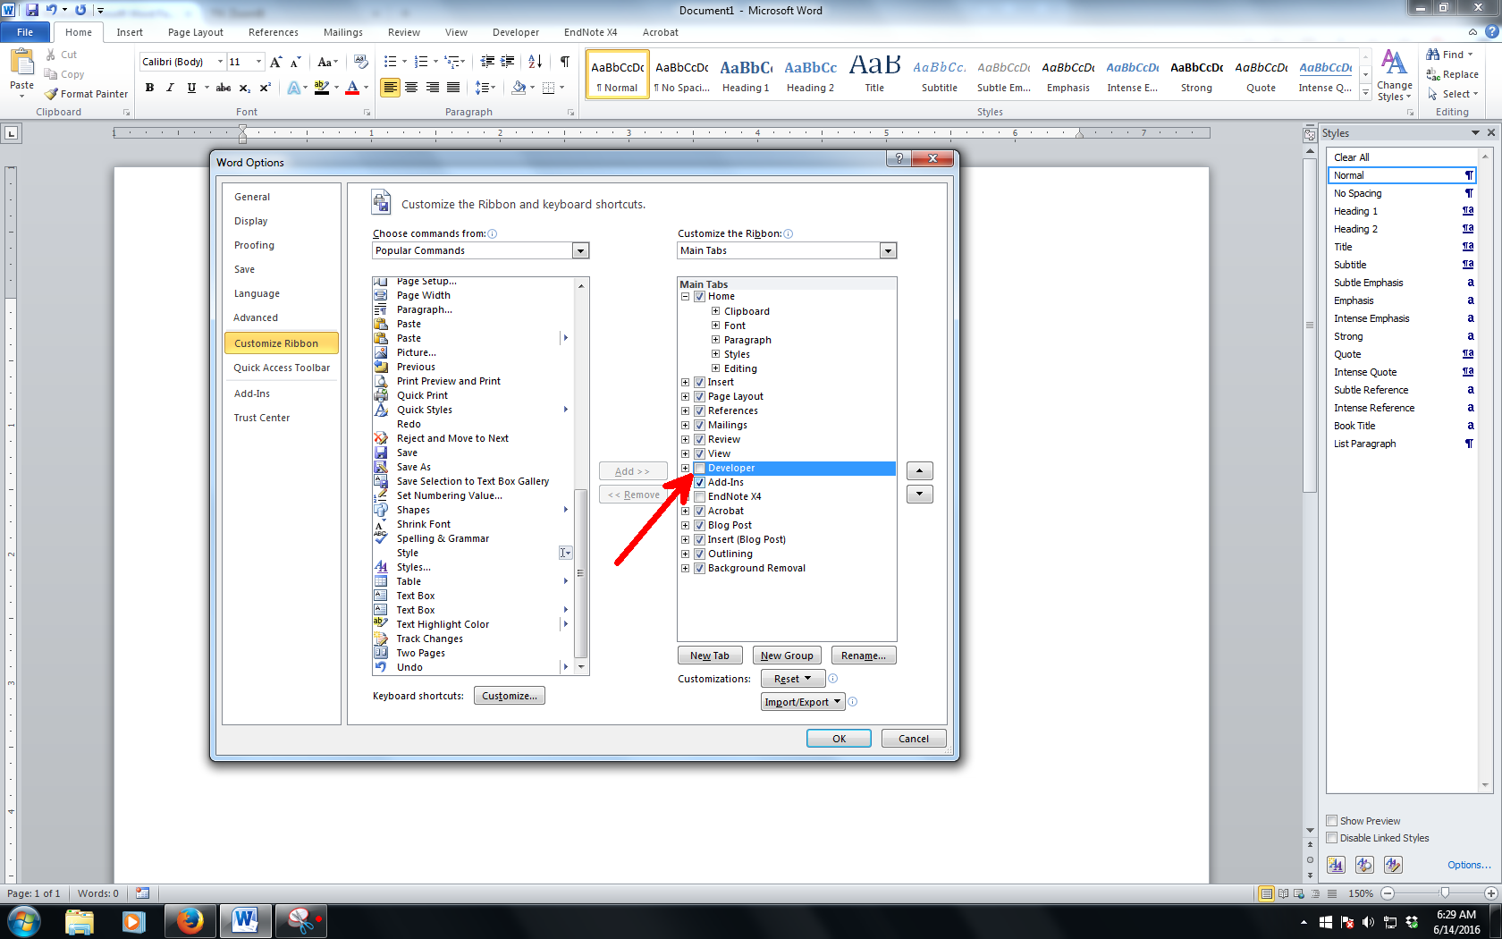

Figure 1.1: Enabling the Developer Tab

Source: Zuli (2016). Use style named *Caption for text in Figure UniMAP* for any text here.

### Navigation Pane

Navigation pane is where you can browse through your thesis based on its heading name. To enable it, please refer to

Figure 1.2. The option to enable navigation pane resides in View ribbon.

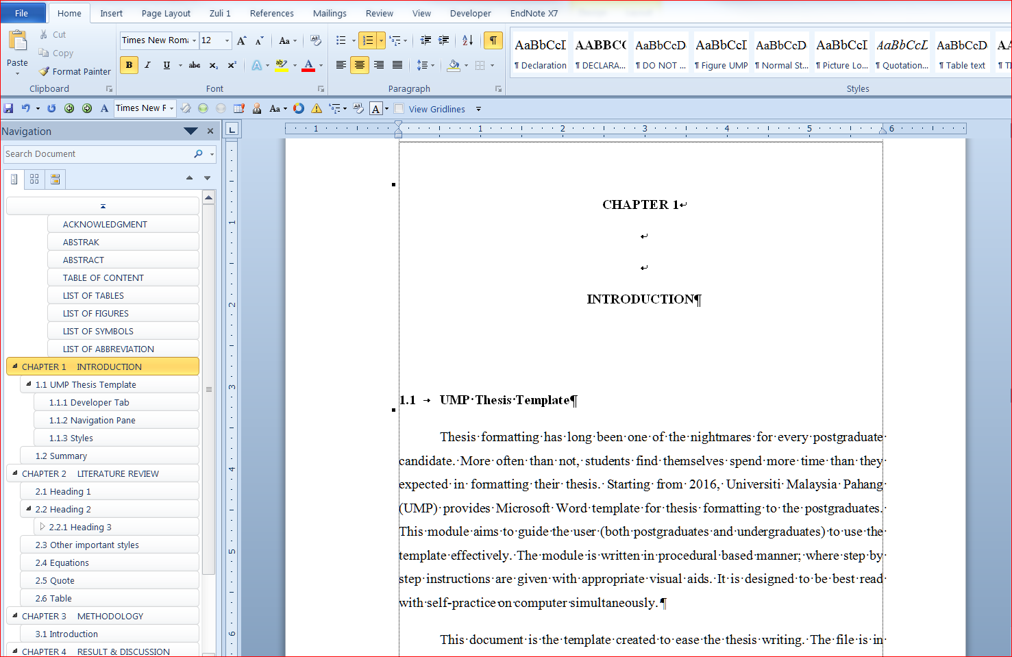

Figure 1.2: Navigation Pane

### Styles Pane

The basic of applying template is Styles. Styles is predefined formatting of text and paragraph. It is most efficient that you put the Styles pane on the right side of the Microsoft Word working environment by click a small arrow as shown in Figure 1.3. If your pane is floating, click and hold the windows and put it at the right side of the windows.

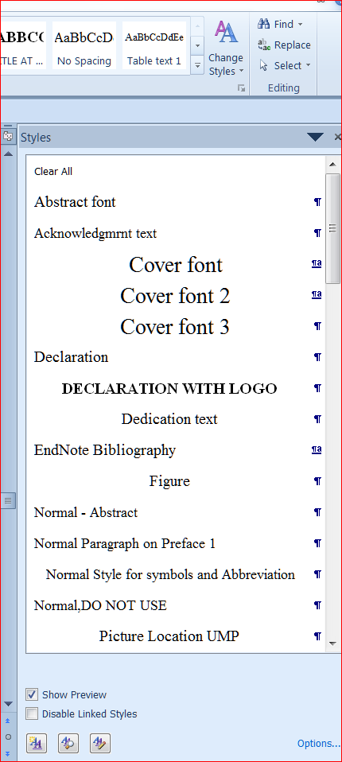

Figure 1.3: Enabling Styles Pane

Once secured on the right side of the working environment, the Styles Pane should look like Figure 1.4.

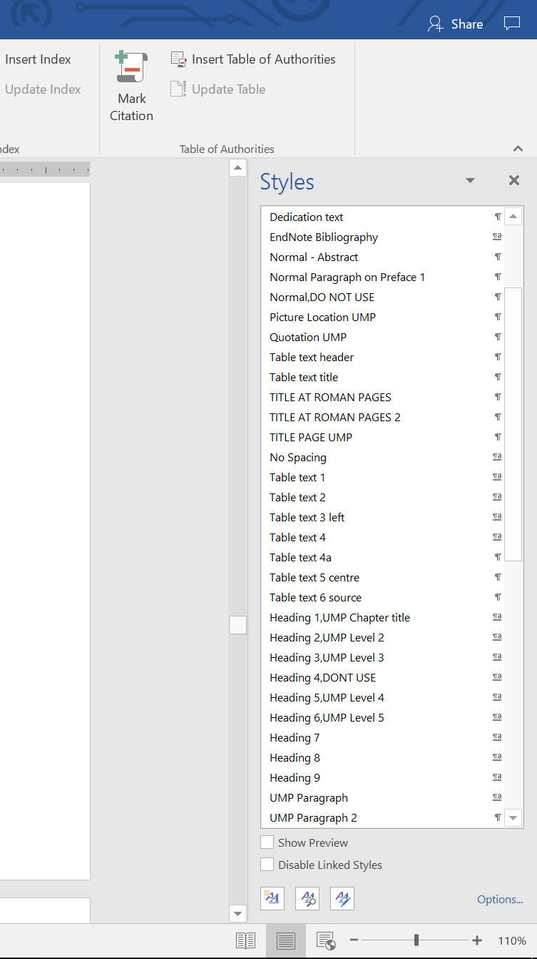

Figure 1.4: Syles Pane on right side of the window

Figure 1.5: This is just a simulation. Syles Pane on right side of the window Once the PC is ready, you can familiarize yourself with the styles in this template. Some of the styles will be explained in Chapter 2

## Summary

Once the PC is ready, you can familiarize yourself with the styles in this template. Some of the styles will be explained in Chapter 2.

# LITERATURE REVIEW

## Heading 1

Heading 1 is used for chapter naming. In this template, it is called *Heading 1, UniMAP Chapter Title*. In most cases, thesis will have around five to seven chapters.

## Heading 2

The styles used for this subchapter 2.2 is *Heading 2, UniMAP Level 2*.

### Heading 3

The heading for Subchapter 2.2.1 is formatted with *Heading 3, UniMAP Level 3*.

##### Heading 4

In this template, Heading 4 is not used. Instead, the heading for level 4 will be using the *Heading 5, UniMAP Level 4*. That is all the heading styles needed to format a thesis.

## Other important styles

All styles developed in this template are essential to a proper thesis formatting. The most widely used style is UniMAP Paragraph. This very paragraph is formatted by *UniMAP Paragraph* syles.

Another important one is the caption styles. All pictures in this template are formatted by using *Caption for Equation* styles.

## Equations

As shown in Equation 2.1, all equations must be systematically numbered. To insert any equation, copy the whole equation and numbering below and paste on your desired location. After that, edit the equation. The style for equation is *Caption for Equation UMP*.

|  |  |
| --- | --- |
|  | 2.1 |

The paragraph after an equation of a figure, has to be formatted in *UniMAP Paragraph 2*. This is to allow some space between the paragraph and the equation or the figure’s caption. This paragraph is using *UniMAP Paragraph 2* style.

## Quote

To insert a quote like this, use *Quotation UniMAP* style. Please ensure all quotation are properly cited.

On the Insert tab, the galleries include items that are designed to coordinate with the overall look of your document. You can use these galleries to insert tables, headers, footers, lists, cover pages, and other document building blocks.

The text in paragraph can be formatted using *Table text* style. On the other hand, the style for table’s caption is called *Caption for Table UniMAP*.

Table 2.1: Sample table The text in paragraph can be formatted using *Table text* style. On the other hand, the style for table’s caption is called *Caption for Table UniMAP*

|  |  |
| --- | --- |
| Test | Text |
| Test | Text |
| Test | Text |
| Test | Text |
| Test | Text |

# METHODOLOGY

## Introduction

## Heading 1

Heading 1 is used for chapter naming. In this template, it is called *Heading 1, UniMAP Chapter Title*. In most cases, thesis will have around five to seven chapters.

## Heading 2

The styles used for this subchapter 2.2 is *Heading 2, UniMAP Level 2*.

### Heading 3

The heading for Subchapter 2.2.1 is formatted with *Heading 3, UniMAP Level 3*.

##### Heading 4

In this template, Heading 4 is not used. Instead, the heading for level 4 will be using the *Heading 5, UniMAP Level 4*. That is all the heading styles needed to format a thesis.

##### Heading 4

In this template, Heading 4 is not used. Instead, the heading for level 4 will be using the *Heading 5, UniMAP Level 4*. That is all the heading styles needed to format a thesis.

## Other important styles

All styles developed in this template are essential to a proper thesis formatting. The most widely used style is UniMAP Paragraph. This very paragraph is formatted by *UniMAP Paragraph* syles.

Another important one is the caption styles. All pictures in this template are formatted by using *Caption for Equation* styles.

## Equations

As shown in Equation 2.1, all equations must be systematically numbered. To insert any equation, copy the whole equation and numbering below and paste on your desired location. After that, edit the equation. The style for equation is *Caption for Equation UMP*.

|  |  |
| --- | --- |
|  | 3.1 |

The paragraph after an equation of a figure, has to be formatted in *UniMAP Paragraph 2*. This is to allow some space between the paragraph and the equation or the figure’s caption. This paragraph is using *UniMAP Paragraph 2* style.

## Quote

To insert a quote like this, use *Quotation UniMAP* style. Please ensure all quotation are properly cited.

On the Insert tab, the galleries include items that are designed to coordinate with the overall look of your document. You can use these galleries to insert tables, headers, footers, lists, cover pages, and other document building blocks.

The text in paragraph can be formatted using *Table text* style. On the other hand, the style for table’s caption is called *Caption for Table UniMAP*.

Table 3.1: Sample table

|  |  |
| --- | --- |
| Test | Text |
| Test | Text |
| Test | Text |
| Test | Text |
| Test | Text |

# RESULT & DISCUSSION

## Introduction

# CONCLUSION

## Introduction

|  |  |  |
| --- | --- | --- |
|  |  |  |
|  |  |  |

REFERENCES

Use reference manager such as Mendeley or Endnote to generate references list here.

APPENDIX A  
SAMPLE APPENDIX 1

For Appendices Heading use TITLE AT ROMAN PAGES style.

APPENDIX B  
SAMPLE APPENDIX 2

For Appendices Heading use TITLE AT ROMAN PAGES style.